Moodle Student Introduction

StEmlyns has chosen Moodle as its main Virtual Learning Environment (VLE) to help support your learning – whatever course you are studying.

Moodle courses are created by your tutors so you can access learning resources and communication facilities at any time and any place.

This handout gives you a basic introduction to using Moodle.
You will find it easy to use and will learn a lot more about Moodle facilities as you use it to support your studies and your learning.

This handout covers:
- Home Page, Logging In, Update Profile
- Accessing your course(s), The Course Page.
- For new starters in EM the enrolment key is listed below.

Home Page
Use your web browser to get to the StEmlyns classroom home page:
- http://classroom.stemlyns.org.uk/

Moodle Home Page

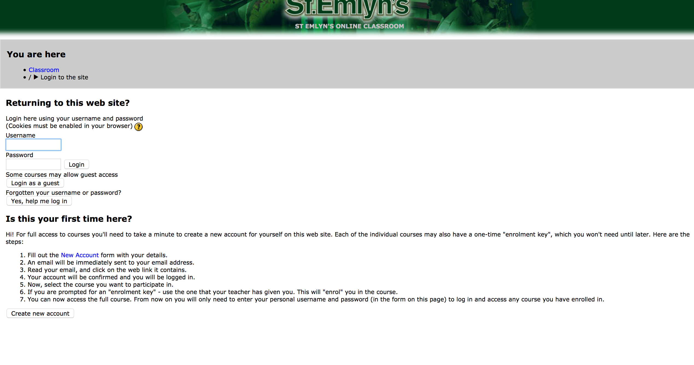

If you are new to moodle on St.Emlyn’s you will need to generate a username and password. If you have an old password you can use the old one. If you need to register as a new user click on the button at the bottom left ‘Create new account’

Moodle registration page
As a new user you will be asked to fill in some basic details on the screen below. Once complete you will be sent an email to confirm that you are a real person. Click on the link in the email to complete your registration.

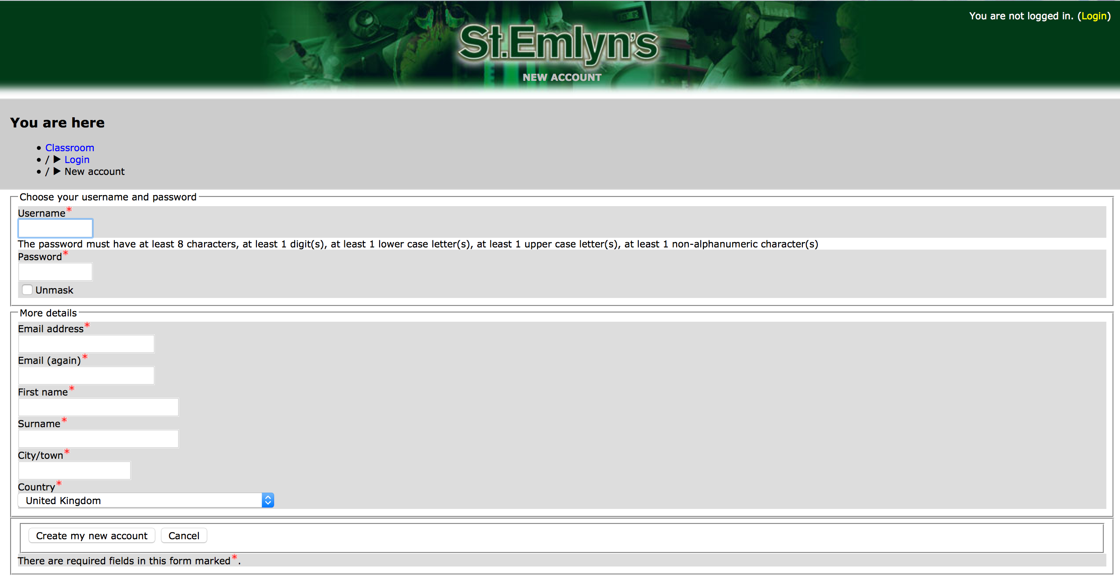

Moodle courses page
Once you have your username and password you can return to http://classroom.stemlyns.org.uk/ and log on. You should then see a page that looks like this.

If you have difficulty logging in, try the following steps:
- Try typing your username and password again – more carefully this time.
- Try typing your password in CAPITALS rather than lower case.
- Contact your tutor to check you have the right details.

As a new starter in ED you should click on the course entitled ‘Junior docs EM introduction’.

If you are asked for an enrolment key it is - Email stemlyns@gmail.com for enrolment key

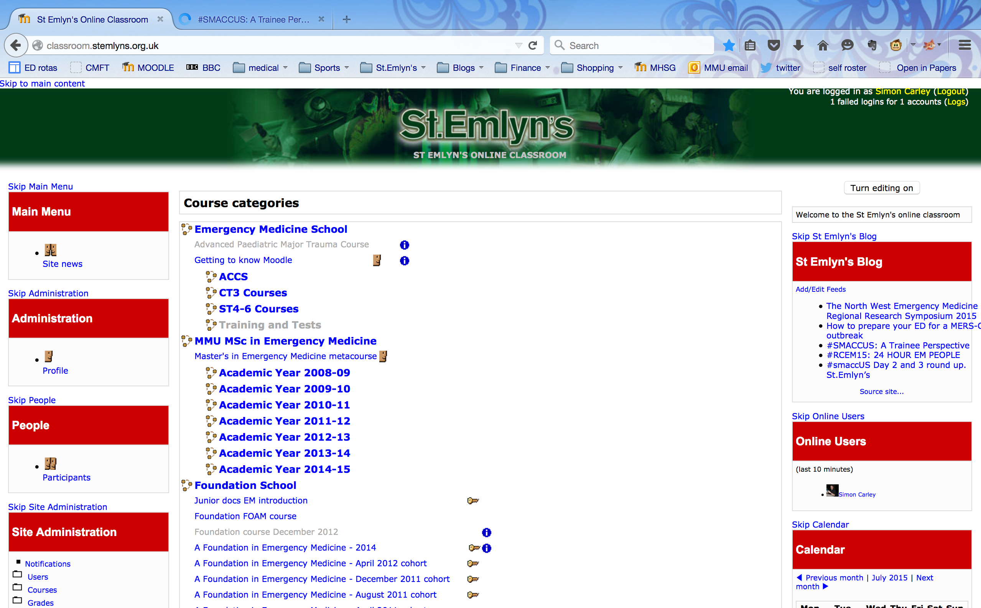

Once logged in, your name appears in the top right of your home page.

You should see details of the courses to which you have been assigned and you will now be able to access each course individually. Do not be concerned if you appear to enrol on one course, but end up with two courses on this page. That happens when we want to introduce a separate generic course such as the “Getting to know Moodle” course that can help you see the features of moodle. For new starter ED docs we use a limited set of features, the majority of which you will already be familiar with. The getting to know moodle course is there as extra support and for interest. Remember that you can always contact your educational supervisor if you need specific help with the functionality of the system.

If you aren’t enrolled on any Moodle courses yet, you will get a list of Course Categories that you can browse through to find your course(s). Your tutor should have told you the course title and told/shown you where your course can be found.

Accessing Your Course(s)
Course overviews show you the course title, the tutors and a brief description of the course.

Click on the course title to enter the course.

You should see the course page like that shown below.

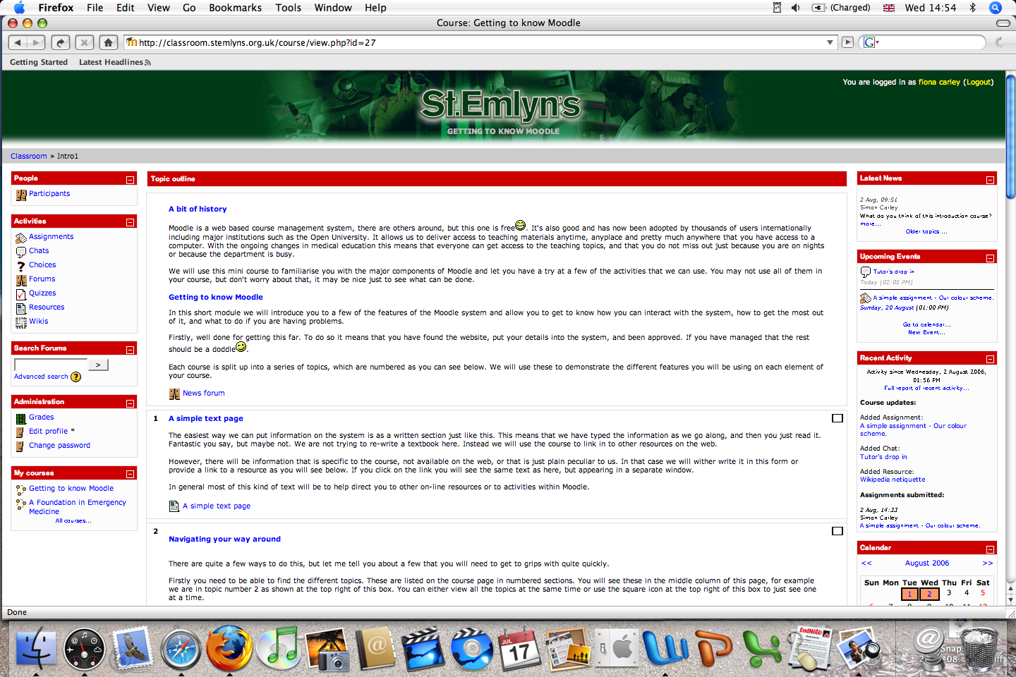

Some courses are protected by a key. If so you might see something different (depending on how your tutor has setup your enrolment onto Moodle) – see below. You may need an Enrolment Key (a course specific password) to get access to your course. Your tutor will have told you what this key is.

For the Junior docs EM introduction course the enrolment key is Email stemlyns@gmail.com for enrolment key

If you have problems getting into your course, contact your educational supervisor in the first instance or call in to the department for further help.

If you have not used Moodle before we want you to start with the “Getting to know Moodle” course. This will take you on your first steps into on-line learning. We really hope you get lots out of this course and enjoy your t bime with us. Please send any feedback to stemlyns@gmail.com

Appendix 1: Common File Types

Image | File Type  Extension | Comments
 | MS Word  doc | Works well if you have MS Office or MS Works on your PC. Other business software may not be able to open this file format.
 | MS PowerPoint  ppt, pps | You will need MS Office on your PC to run these presentations.
 | Portable Document Format  pdf | A common file type on the Internet. Get the Adobe Reader free from http://www.adobe.com/ to open and print these files.
 | World Wide Website  htm, html, shtml, asp, xml, php, jsp etc | You will need a web browser (Internet Explorer, Netscape, Opera etc) to see these web pages. You may also need to download plug-in software to view some web page components.
 | General  various | Other file types no recognised by the computer.
 | Image  jpg, jpeg, gif, png | If you don’t have image display software, insert these files into a word document to view them.
 | Audio  Wav, mid, mp3 | You will need audio software to hear these sound files.
 | Video  mpeg, avi, mov | You will need video software to see and hear these video files.
 | Compressed File  zip | These ZIP files should be de-compressed or un-zipped into a folder to see what files they contain. Use WinZip etc to do this.

Appendix 2: Moodle Activity Images

Image | Activity | Comments
 | Forum  (Discussion Group) | You can post messages or reply to messages from other students on any day or time.  Remember to visit the Forum regularly to see what’s being said and to have your say too.
 | Chat | This is real-time text based conversation.  For a chat session, everyone has to be online at the same time – sessions are held on specific dates and times.
 | Quiz | A question set created by your tutor and marked automatically. These can be for self assessment or as end of topic tests.
 | Assignment | This facility allows you to upload your assignment to Moodle for marking. Tutor feedback on your work and a grade are shown in your personal ‘Grade Book’.
 | Choice | A type of voting system where the opinions of all students on the course can be collected for specific questions.
 | Journal | This is a space private to you and your tutor where you can reflect on specific study activities or on your learning in general.
 | Glossary | A list of words and acronyms along with their meaning or definition. Some can be created by the student group themselves.
 | Lesson | A series of information pages followed by a question or a set of choices. The route through the lesson depends on how you answer the questions and the choices you make.
 | Wiki | This facility allows a group to collaboratively create a web based information site where all contributions, editing and updates are tracked.
 | Workshop | Tutors can set up a situation where students act as tutors to mark their own and other students work according to set criteria.
 | Learning Survey | One of three surveys that look at your attitude and approach to using online resources for learning.

Moodle is an acronym, it stands for ‘Modular Object-Oriented Dynamic Learning Environment’

